Documentation for installation

First I began by installing creating a folder to have all the logs and files for the ISO.

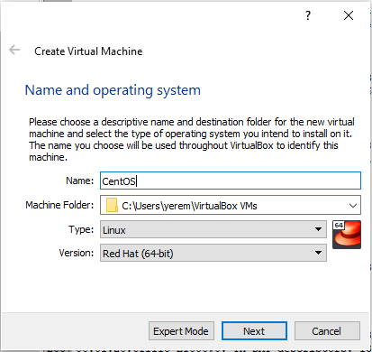

I choose the amount of ram I wanted dedicate to this machine, I decided to go with 4 since it was a good amount for the task’s I’d be doing. I also had to select the storage and I went with a fixed space on my hard drive since it was faster then allocated.

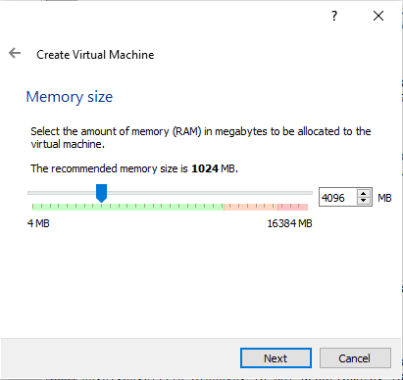

This is the Install screen of the machine running, I went and tested the media and installed CentOS ,

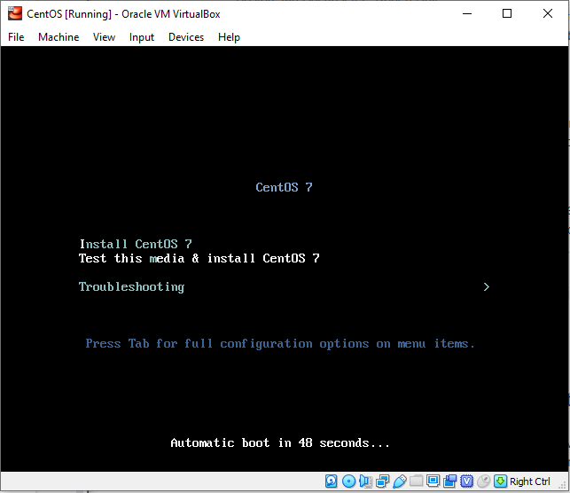

I selected the software and what I wanted installed on the virtual machine, this also allowed me to select any additional repositories I wanted to add.

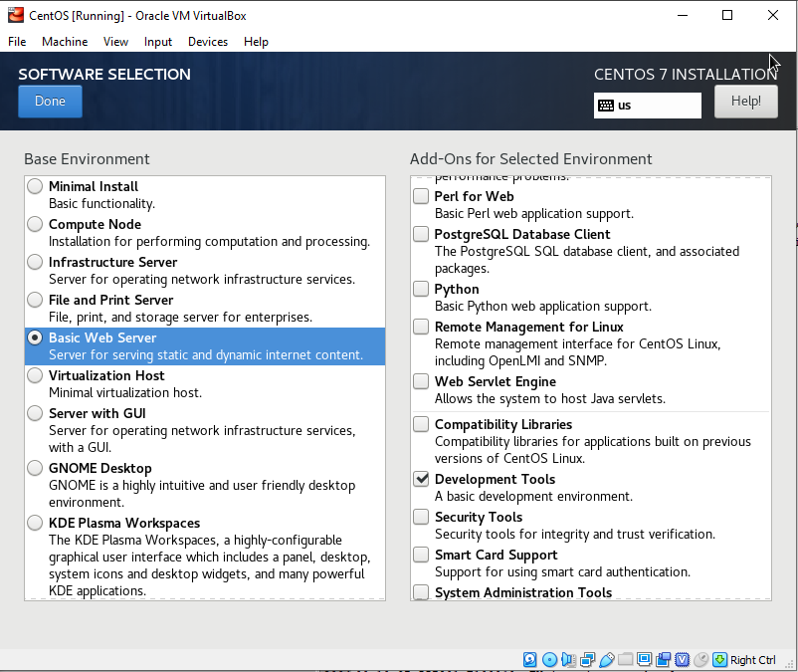

In here I created my username and password for the machine, while it had me run this I was able to complete the setup of the software

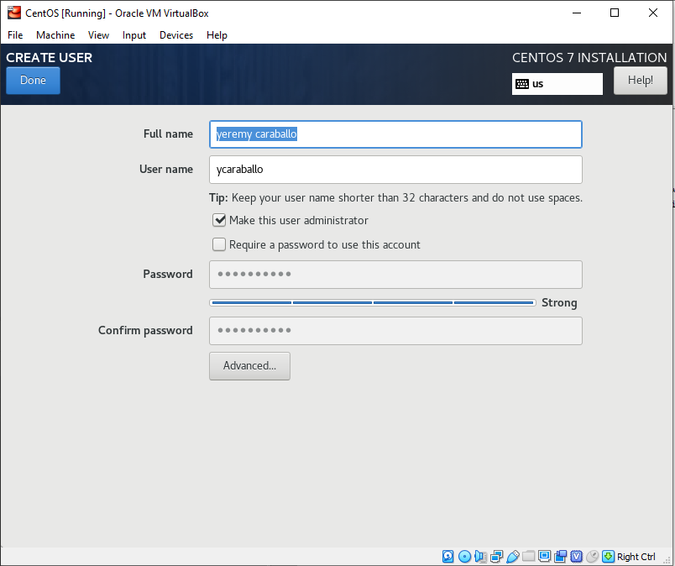

This is my server terminal running which I setup. I also had my script and users added on this.

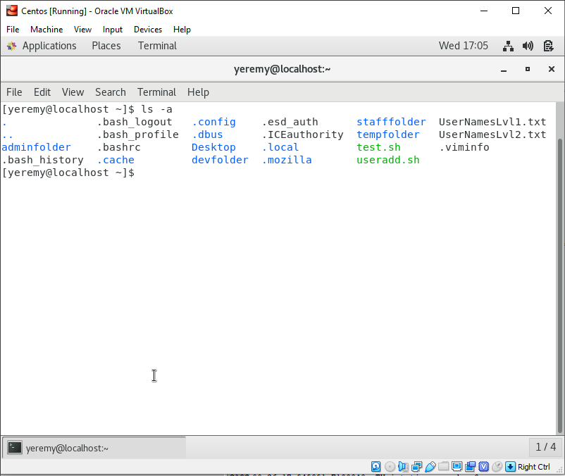

Setup my username and password, was able to access the root and run a few commands

Installed an ubuntu into computer, setup username for server as well as password

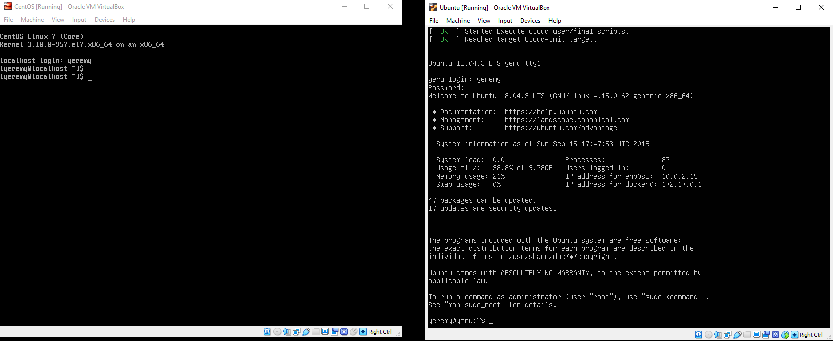

Configured account, created some files, attempted to create new user